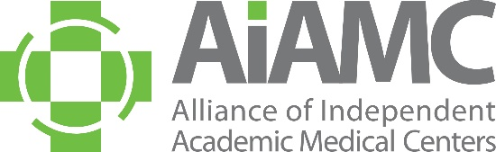

ALLIANCE OF INDEPENDENT
ACADEMIC MEDICAL CENTERS
2021 Annual Meeting
Call for Poster Abstracts

All AIAMC members are invited to submit abstracts for poster presentation at our 2021 Annual Meeting, to be held March 25th – 27th at the Loews Vanderbilt Hotel in Nashville, Tennessee. We encourage you to share this call with AIAMC-member colleagues, especially your residents who may not typically receive these announcements. Abstracts are due no later than September 25, 2020 and all submitting authors will be notified of the committee’s decision by mid-October.

NEW THIS YEAR: An informational “How-To” webinar will be held on Tuesday, September 15th at 1:00 pm Eastern Time. Two members of the 2021 Annual Meeting Planning Committee will share tips and tools for creating poster abstracts that yield stronger scores during the review process. Save this date now and plan to attend. There is no charge for the webinar; however, pre-registration is required. Watch future issues of AIAMC This Week for registration information or reach out to Kimberly Pierce-Boggs (kimberly@aiamc.org) to learn more.

Criteria for Selection:

Introduction: clearly articulated context for project or research study, including relevant literature

Hypothesis/Aim Statement: clearly stated purpose of the project or research study
Methods: clear description of how the project was conducted and/or implemented, with sound and appropriate project design

Results: clear and unambiguous statement of what changed and how

Conclusions: implications of the project beyond the local setting
All accepted poster presenters are required to register for the conference. Please do NOT submit an abstract if your attendance at the Annual Meeting is questionable. Accepted posters will be on display for the entire conference, i.e., from Thursday, March 25th thru Saturday, March 27th. On Saturday morning, March 27th, the top abstracts chosen for oral presentation will be presented in a “poster slam” format, followed by a staffed poster display of all posters accepted. Poster presenters are asked to make travel plans accordingly. In accordance with AIAMC policy, all registration fees and travel expenses will be the responsibility of the presenter’s home institution. Submitting an abstract is a commitment that, if the abstract is accepted, all poster presenters will attend the 2021 Annual Meeting and conduct sessions at the times assigned.
Submission Process:
The abstract must be completed and returned no later than September 25, 2020 to Kimberly Pierce-Boggs via email kimberly@aiamc.org or fax 888-AIAMC11 (888-242-6211). Please limit abstracts to no more than 500 words.

Poster Session Topics:
Poster content should support the meeting theme of Uniting for Transformational Change as follows:

- Ethnicity and Diversity
- Social Determinants of Health
- Teamwork/Collaborative Practice
- Well-Being During Times of Stress
- The Courage to Lead
Poster Display Information:
A suggested PowerPoint template of the poster will be emailed to all selected candidates. The poster board surface must be 42” wide by 30” high (landscape orientation). Poster displays will be assembled on Thursday, March 25th between 8:00 a.m. and 11:00 a.m. They will remain on display throughout the Annual Meeting and National Initiative VII Meeting Four, which concludes mid-day on Saturday, March 27th. Any posters not removed at the conclusion of the meetings will be discarded by the hotel staff.
We encourage you to submit an abstract and look forward to seeing you at the meeting!

